Problem Queries

1.Can you get all data about movies?

select * from movies;

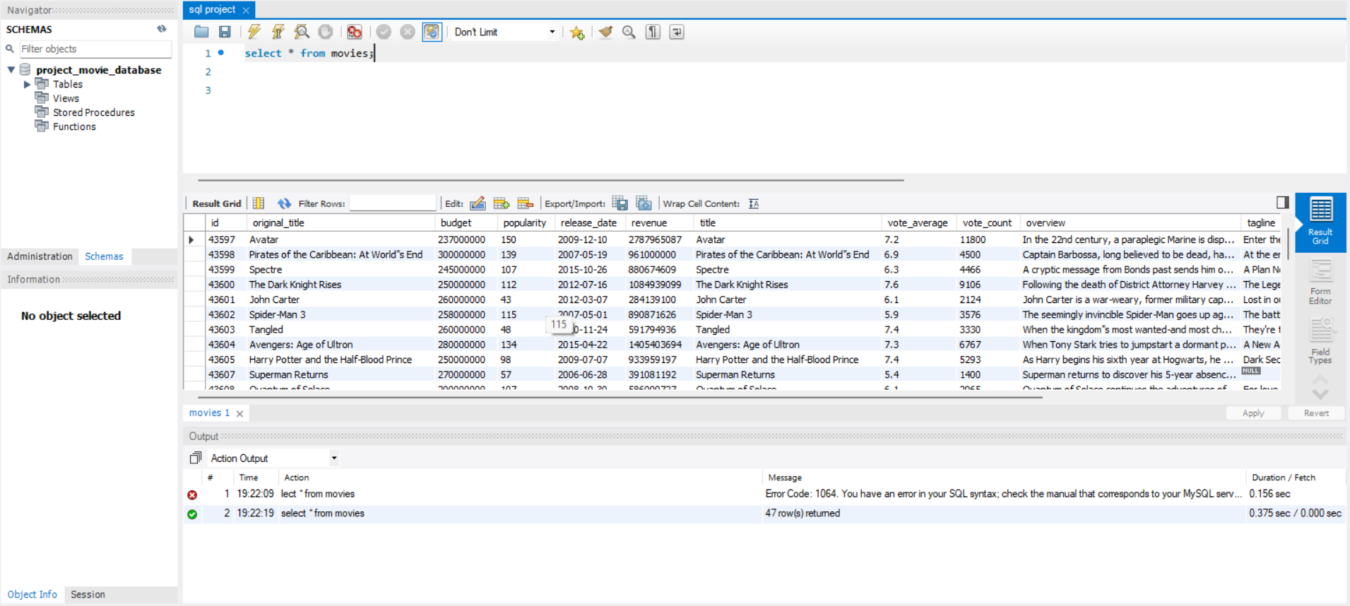
2.How do you get all data about directors?

select * from directors;

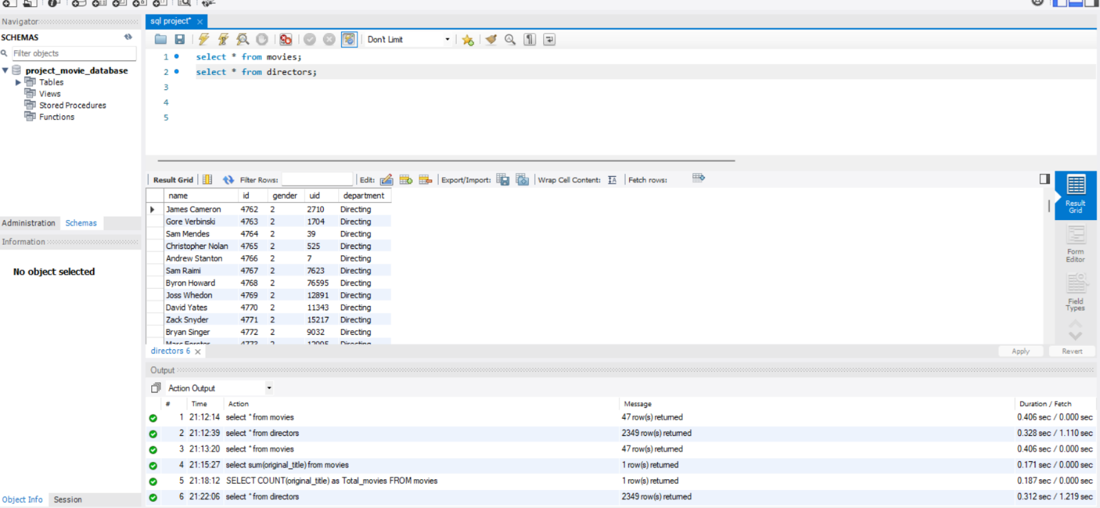

3.Check how many movies are present in IMDB?

SELECT COUNT(original_title) as Total_movies FROM movies;

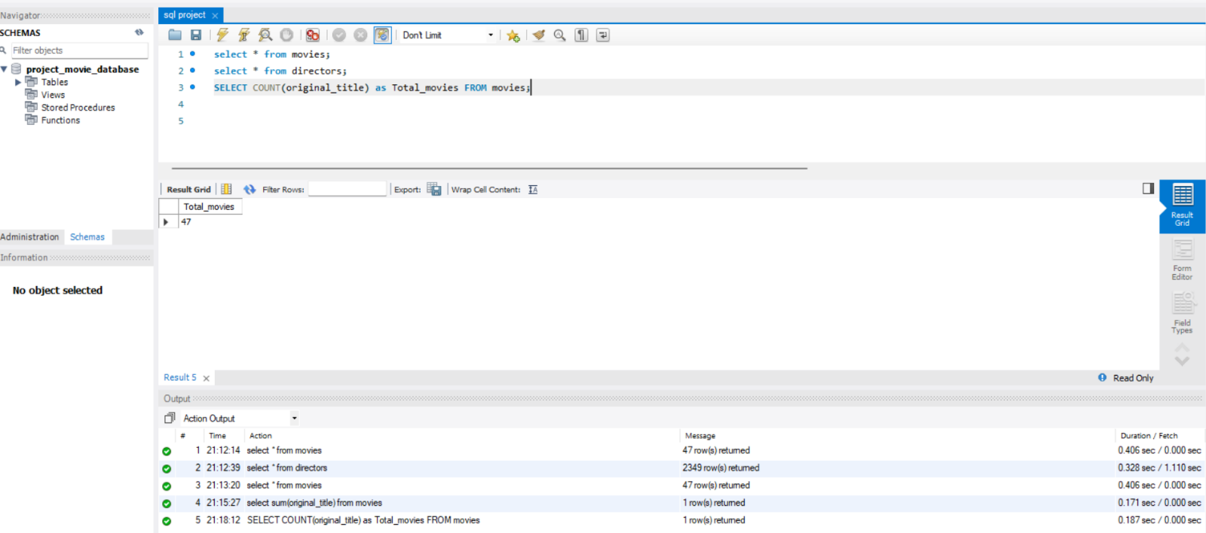

4.Find these 3 directors: James Cameron ; Luc Besson ; John Woo?

select * from directors where name in ('James Cameron','Luc Besson','John Woo');

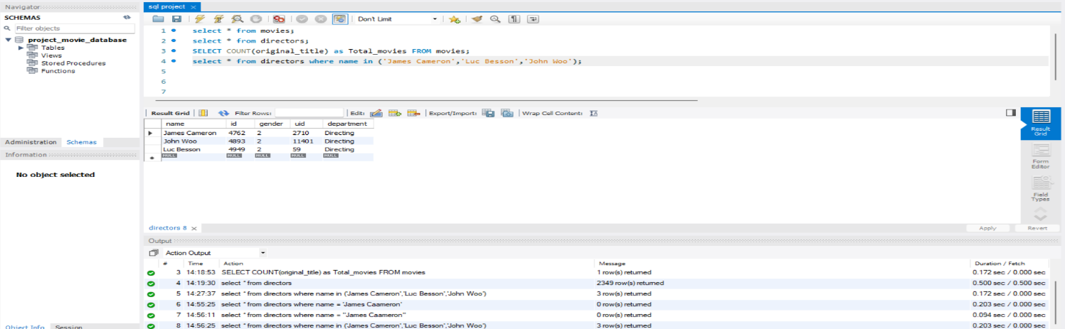

5.Find all directors with name starting with S?

select * from directors where name like 'S%';

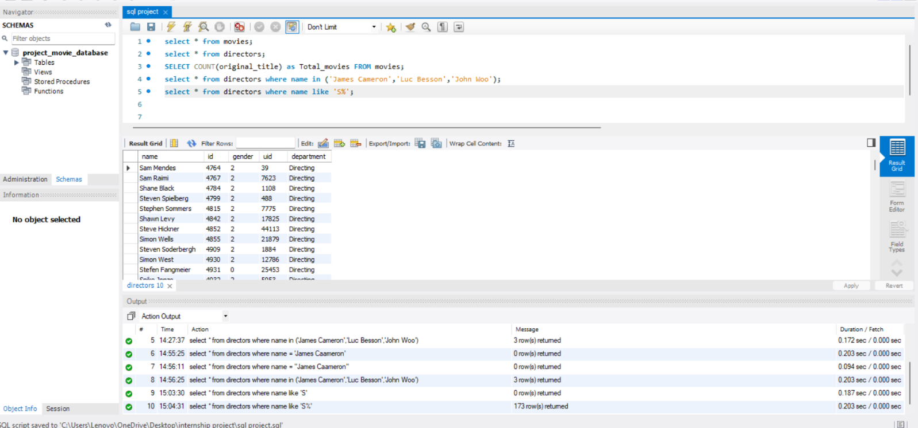

6.Count female directors?

SELECT COUNT(gender) as female_director_count FROM directors where gender = 1;

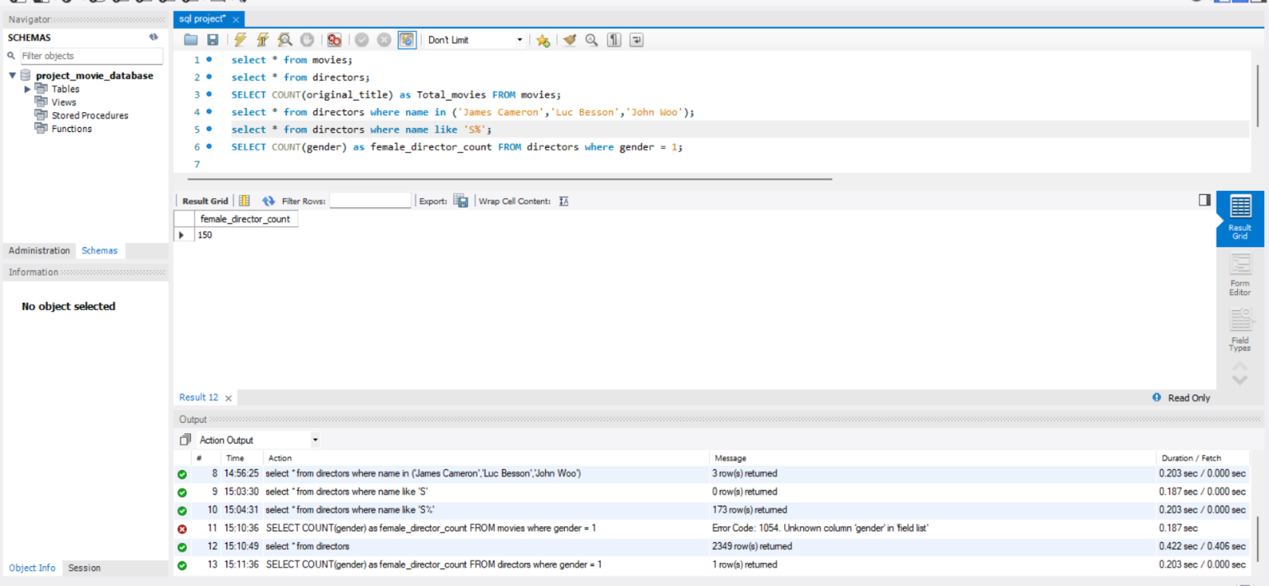

7.Find the name of the 10th first women directors?

select name from directors where gender = 1 limit 10;

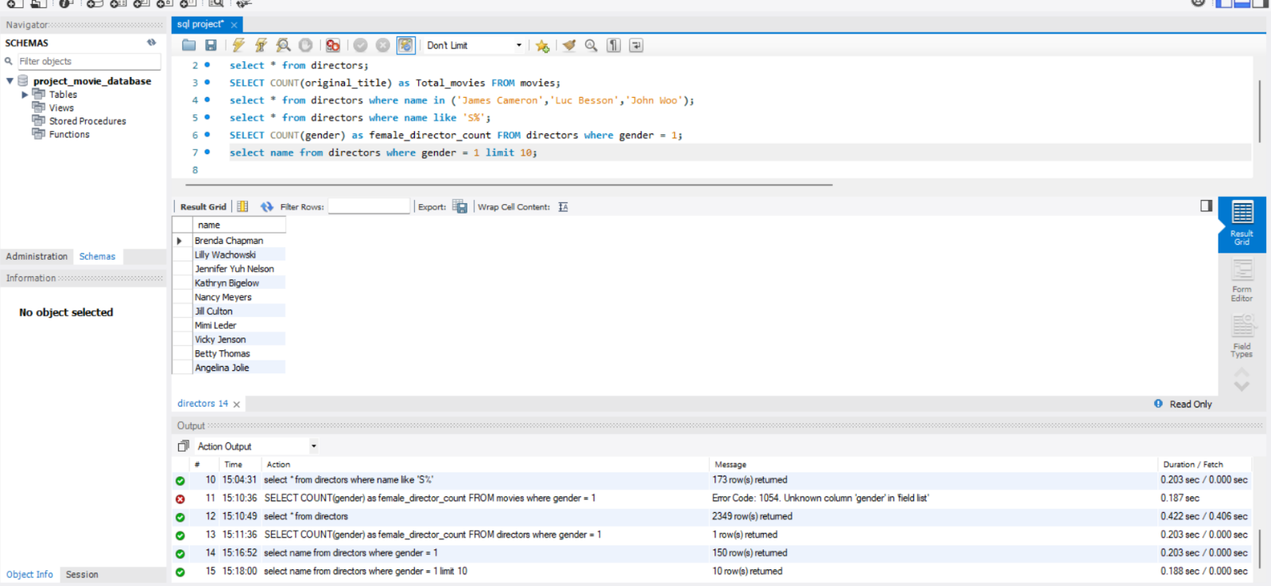

8.What are the 3 most popular movies?

select original_title from movies order by popularity desc limit 3;

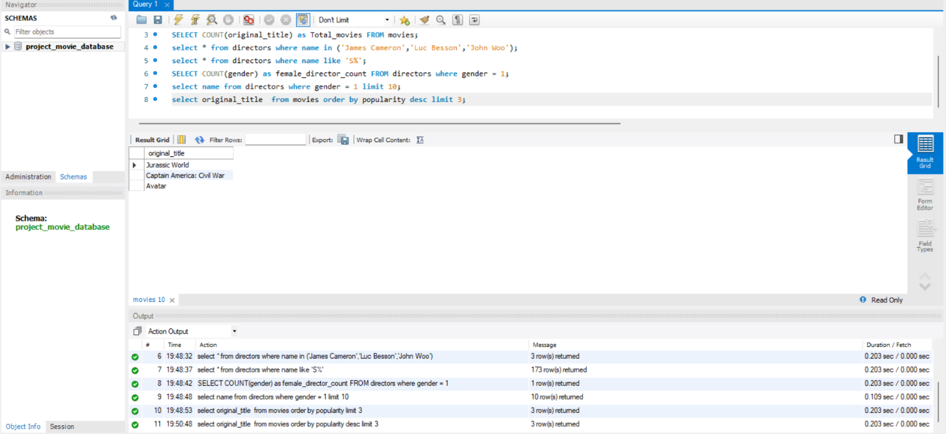

9.What are the 3 most bankable movies?

SELECT original_title FROM movies ORDER BY budget DESC LIMIT 3;

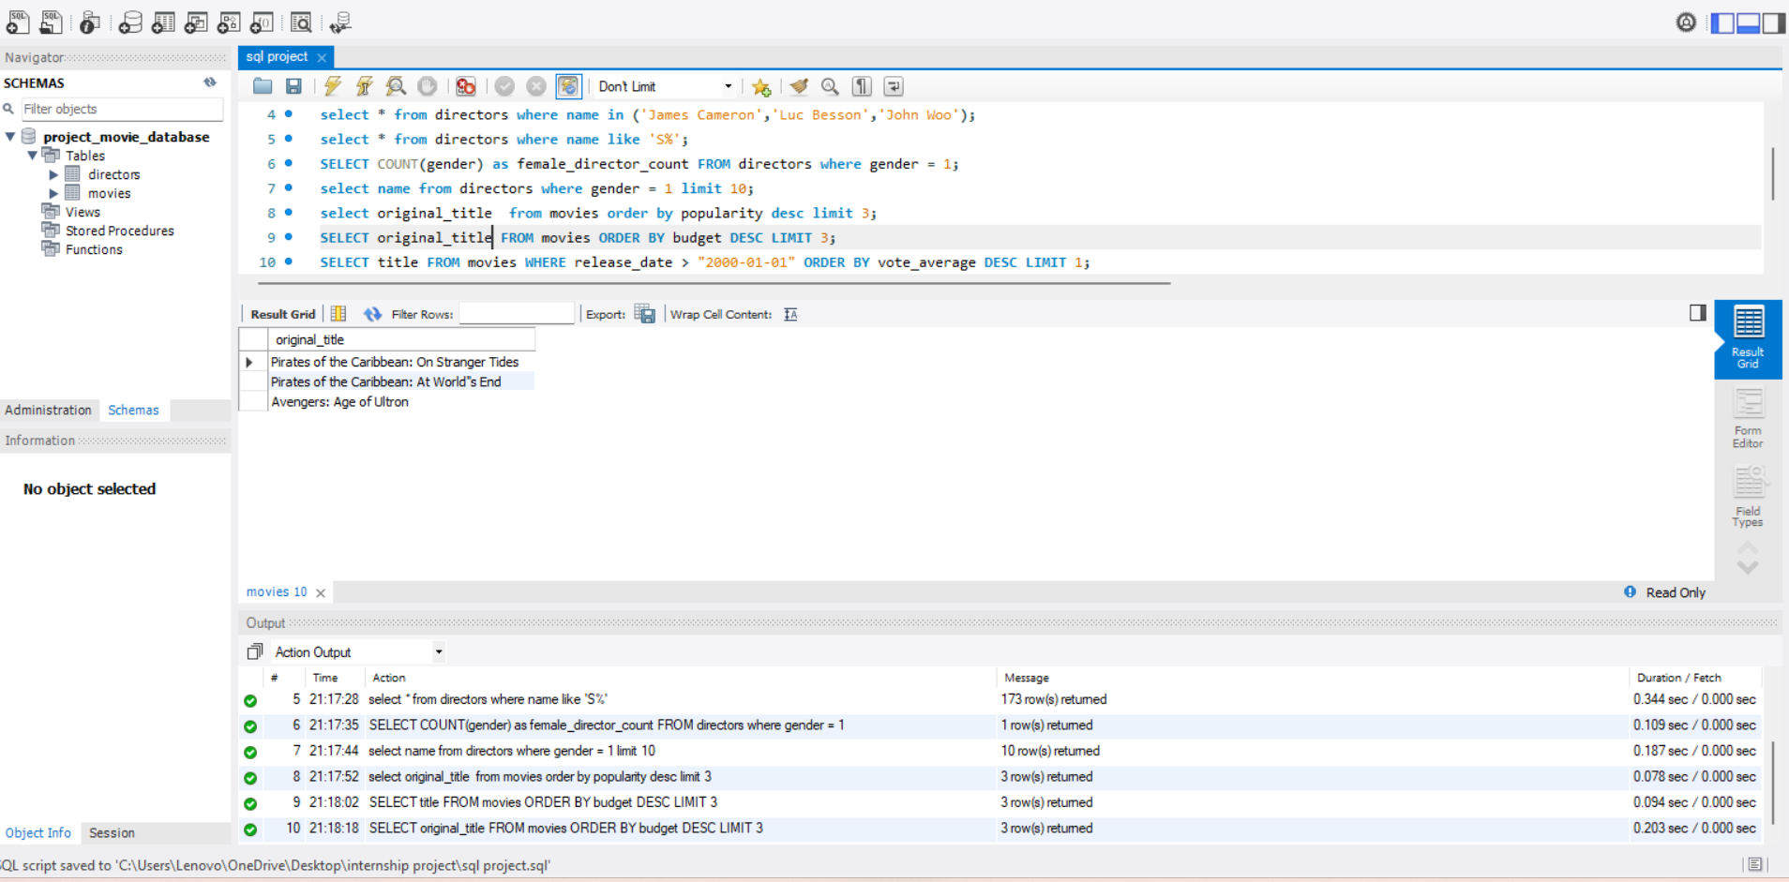

10.What is the most awarded average vote since the January 1st, 2000?

SELECT original_title FROM movies WHERE release_date > "2000-01-01" ORDER BY vote_average DESC LIMIT 1;

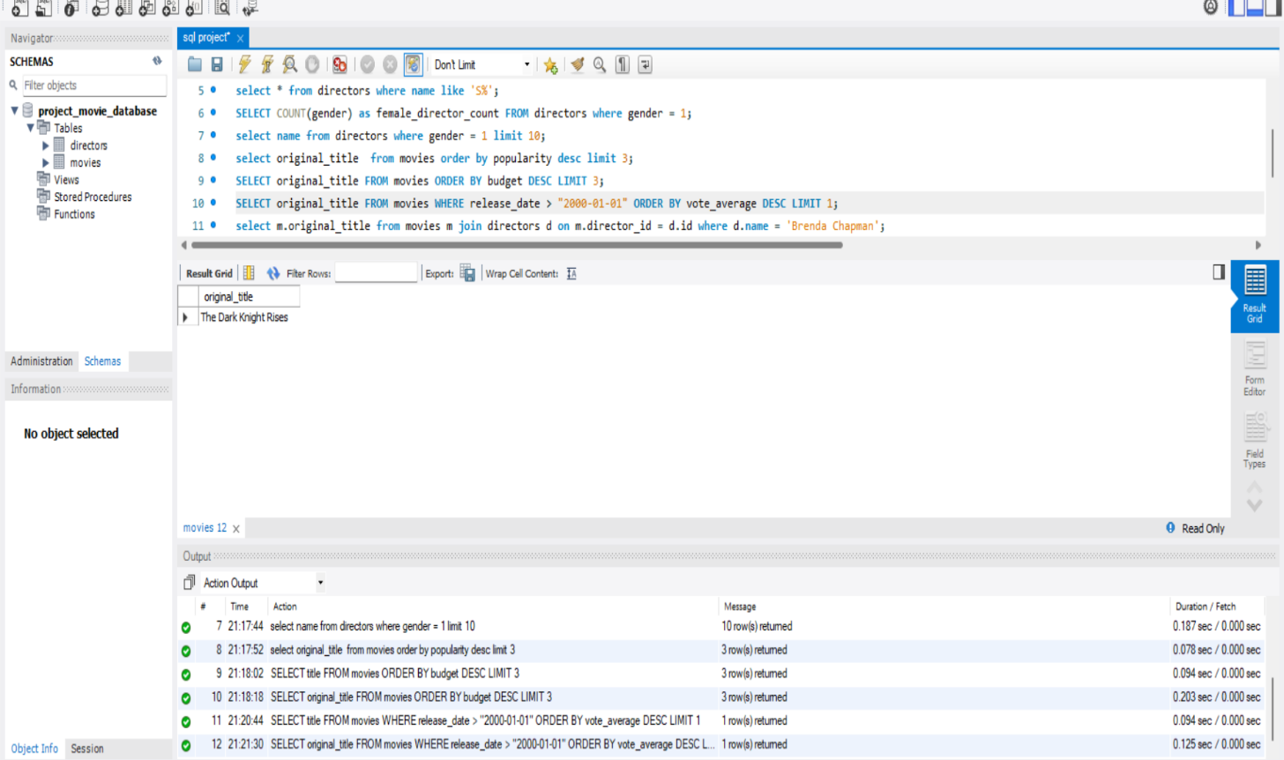

11.Which movie(s) were directed by Brenda Chapman?

select m.original_title from movies m join directors d on m.director_id = d.id where d.name = 'Brenda Chapman';

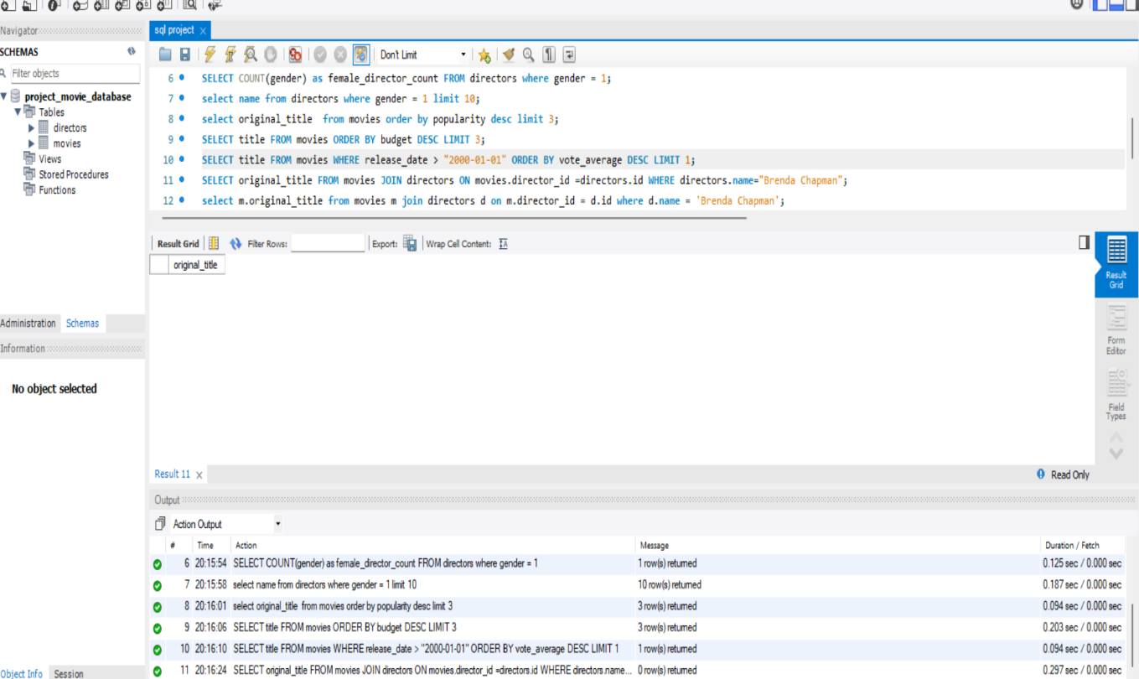

In movies table there is no movie which is directed by Brenda chapman i.e no data related to these director in movies table.

12.Which director made the most movies?

select d.name, count(*) as movie_count from movies m join directors d on m.director_id = d.id group by d.name order by movie_count desc limit 1;

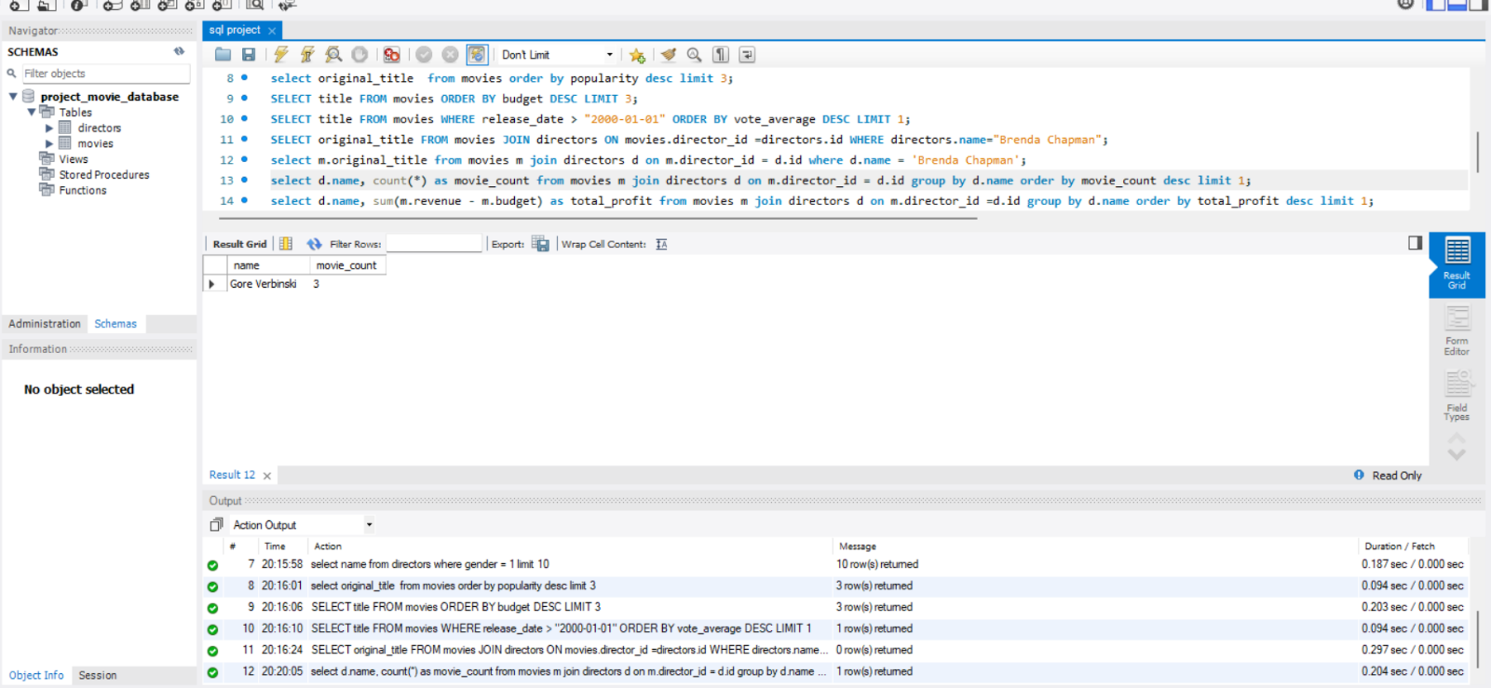

13.Which director is the most bankable?

select d.name, sum(m.revenue - m.budget) as total_profit from movies m join directors d on m.director_id =d.id group by d.name order by total_profit desc limit 1;

